Exp No. | Input |  |  |  |  | Output or parameter to be predicted
 | Pulse On Time (Âµs) | Pulse Off Time (Âµs) | Servo Voltage (V) | Applied Current (A) | Angle of wire | Surface Roughness, Ra (Âµm) | Material Removal Rate (mm3/min) | Kerf Width(mm)
1 | 12 | 12 | 55 | 4 | 60 | 4.137 | 5.866 | 1.378
2 | 12 | 12 | 60 | 3.5 | 60 | 3.752 | 5.556 | 1.277
3 | 8 | 14 | 70 | 5 | 30 | 2.458 | 4.770 | 0.943
4 | 8 | 14 | 50 | 5 | 90 | 3.795 | 5.695 | 1.289
5 | 12 | 12 | 55 | 4 | 60 | 4.225 | 5.957 | 1.400
6 | 12 | 12 | 60 | 3.5 | 60 | 3.782 | 5.653 | 1.286
7 | 8 | 10 | 70 | 5 | 90 | 2.692 | 4.919 | 1.004
8 | 8 | 14 | 70 | 5 | 30 | 2.542 | 4.838 | 0.965
9 | 12 | 13 | 60 | 4 | 60 | 3.561 | 5.442 | 1.227
10 | 8 | 14 | 50 | 5 | 90 | 3.885 | 5.773 | 1.311
11 | 16 | 10 | 70 | 5 | 30 | 3.431 | 5.540 | 1.194
12 | 16 | 10 | 70 | 3 | 90 | 3.195 | 5.021 | 1.135
13 | 8 | 10 | 70 | 5 | 90 | 2.777 | 5.024 | 1.026
14 | 12 | 13 | 60 | 4 | 60 | 3.645 | 5.535 | 1.249
15 | 16 | 10 | 70 | 5 | 30 | 3.529 | 5.643 | 1.219
16 | 16 | 10 | 70 | 3 | 90 | 3.279 | 5.172 | 1.155
17 | 12 | 12 | 60 | 4.5 | 60 | 3.859 | 5.736 | 1.305
18 | 12 | 12 | 60 | 4.5 | 60 | 3.774 | 5.644 | 1.283
19 | 16 | 14 | 50 | 3 | 90 | 4.577 | 5.901 | 1.489
20 | 16 | 14 | 50 | 3 | 90 | 4.487 | 5.797 | 1.467
21 | 8 | 14 | 70 | 3 | 90 | 2.209 | 4.290 | 0.879
22 | 8 | 14 | 70 | 3 | 90 | 2.285 | 4.393 | 0.898
23 | 14 | 12 | 60 | 4 | 60 | 4.026 | 5.785 | 1.347
24 | 14 | 12 | 60 | 4 | 60 | 3.937 | 5.683 | 1.325
25 | 12 | 12 | 65 | 4 | 60 | 3.331 | 5.338 | 1.169
26 | 12 | 12 | 65 | 4 | 60 | 3.415 | 5.440 | 1.191
27 | 8 | 10 | 50 | 3 | 30 | 4.829 | 6.589 | 1.556
28 | 12 | 12 | 60 | 4 | 75 | 3.638 | 5.517 | 1.249
29 | 12 | 11 | 60 | 4 | 60 | 3.925 | 5.752 | 1.322
30 | 8 | 10 | 50 | 3 | 30 | 4.910 | 6.668 | 1.576
31 | 12 | 12 | 60 | 4 | 75 | 3.725 | 5.620 | 1.272
32 | 12 | 11 | 60 | 4 | 60 | 4.017 | 5.850 | 1.347
33 | 16 | 10 | 50 | 5 | 90 | 5.060 | 6.577 | 1.615
34 | 16 | 10 | 50 | 5 | 90 | 4.944 | 6.467 | 1.584
35 | 16 | 14 | 70 | 3 | 30 | 2.963 | 4.848 | 1.074
36 | 16 | 14 | 70 | 3 | 30 | 3.042 | 4.950 | 1.093
37 | 16 | 14 | 50 | 5 | 30 | 4.722 | 6.258 | 1.528
38 | 16 | 14 | 50 | 5 | 30 | 4.812 | 6.331 | 1.551
39 | 12 | 12 | 60 | 4 | 45 | 3.895 | 5.773 | 1.314
40 | 12 | 12 | 60 | 4 | 45 | 3.808 | 5.684 | 1.291
41 | 10 | 12 | 60 | 4 | 60 | 3.531 | 5.519 | 1.222
42 | 10 | 12 | 60 | 4 | 60 | 3.612 | 5.614 | 1.241

Table 5: Hyperparametrs for optimized models
Output | XGB Hyperparameter | XGB R² | SVR Hyperparameter | SVR R² | RF Hyperparameter | RF R² | NN Hyperparameter | NN R²
Surface Roughness | learning_rate=0.05, max_depth=4, min_child_weight=3, n_estimators=200, subsample=0.8, colsample_bytree=0.8 | 0.904 | C=50, epsilon=0.1, gamma='scale' | 0.883 | n_estimators=300, max_depth=10, max_features='sqrt' | 0.870 | hidden_layers=(8,4,2), learning_rate_init=0.01, activation='relu' | 0.887
MRR | learning_rate=0.05, max_depth=4, min_child_weight=3, n_estimators=200 | 0.875 | C=50, epsilon=0.1, gamma='scale' | 0.859 | n_estimators=300, max_depth=10 | 0.840 | hidden_layers=(6,5,4), learning_rate_init=0.01, activation='relu' | 0.831
Kerf | learning_rate=0.05, max_depth=4, min_child_weight=3, n_estimators=200 | 0.918 | C=40, epsilon=0.05, gamma='scale' | 0.877 | n_estimators=300, max_depth=10 | 0.888 | hidden_layers=(5,4,3), learning_rate_init=0.01, activation='relu' | 0.755

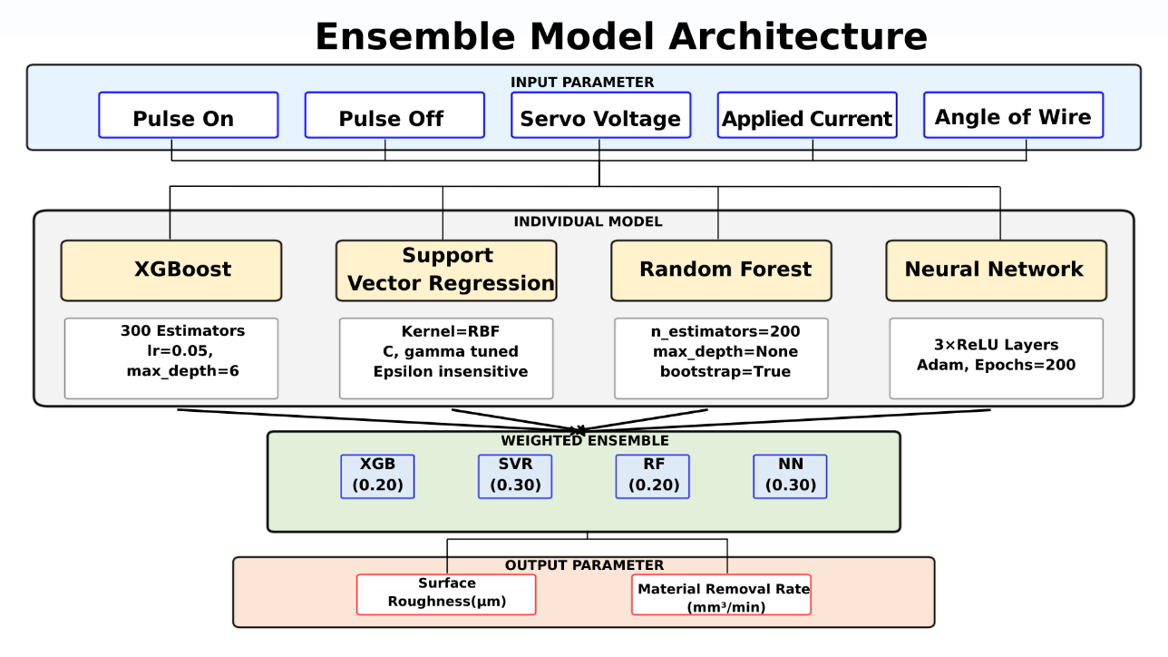

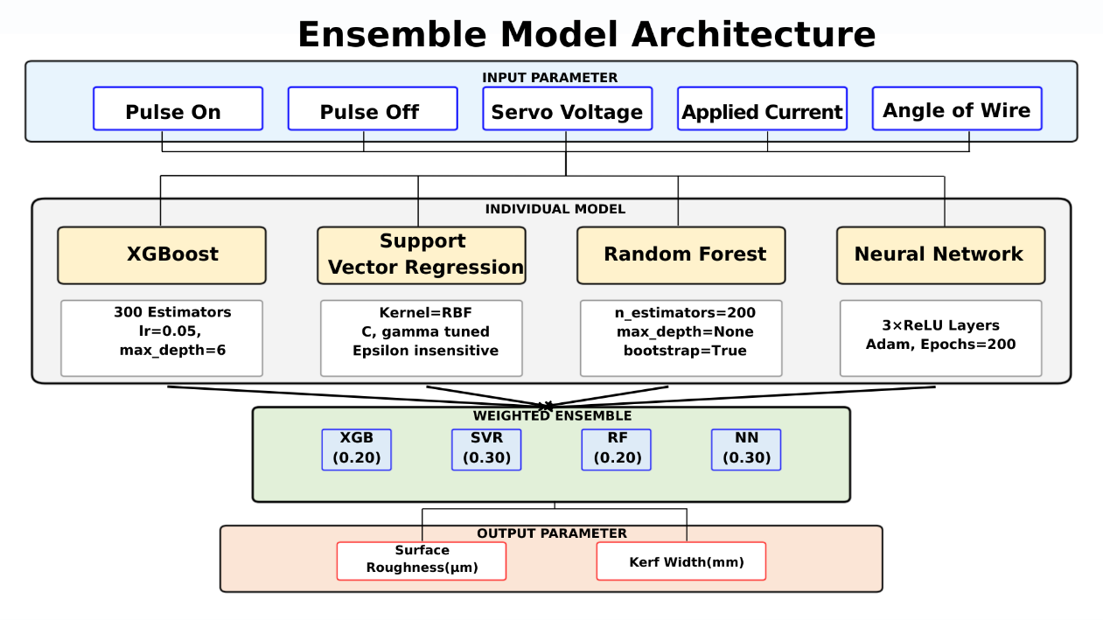

Ensemble Model Performance Summary
Target | RMSE | MAE | R²
Surface Roughness | 0.2098 | 0.1275 | 0.9088
MRR | 0.1840 | 0.1110 | 0.8826
Kerf Width | 0.0521 | 0.0317 | 0.9203
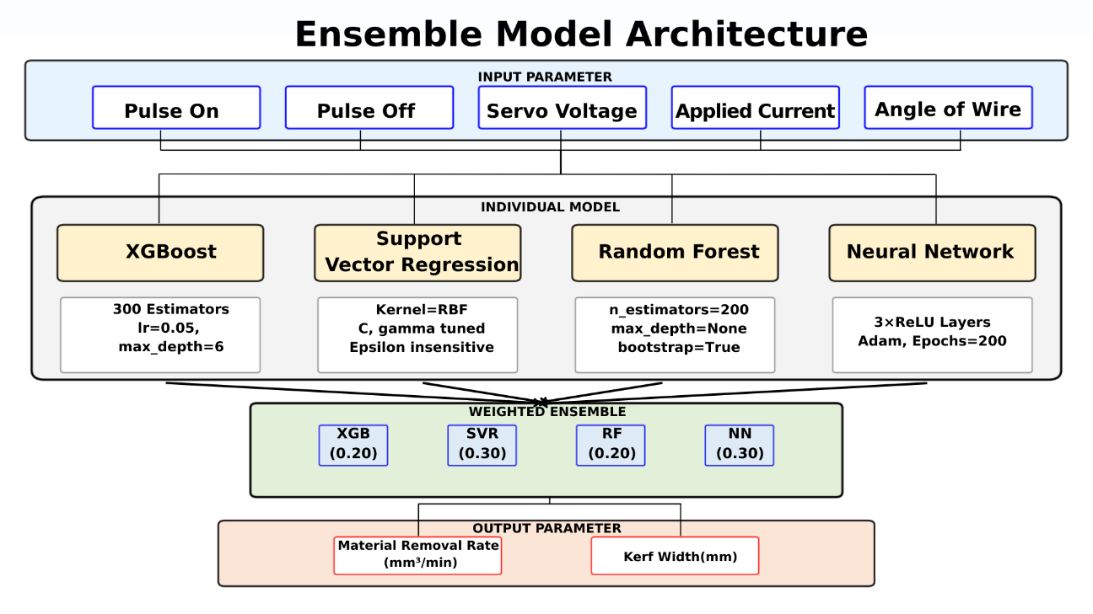

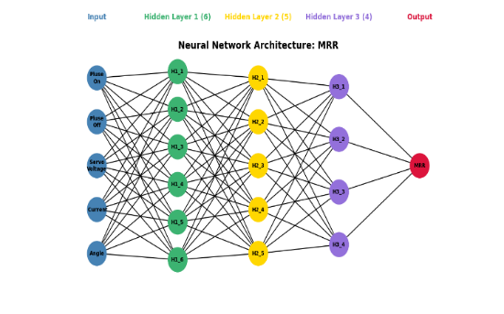
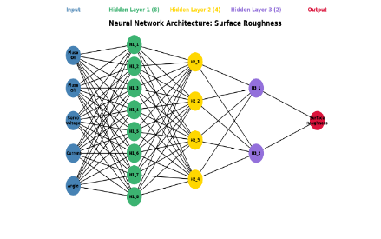

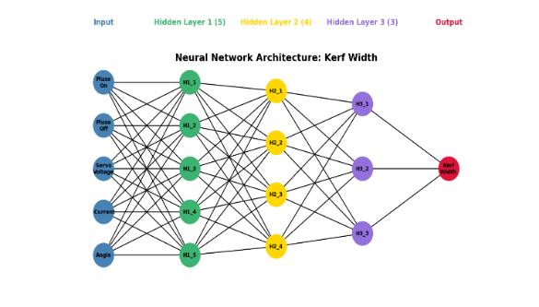

Table 6: Ensemble Model performance.

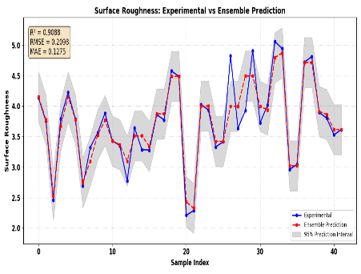
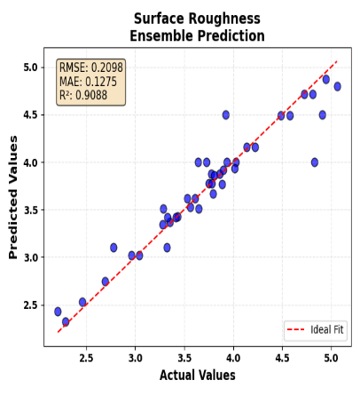
Surface Roughness
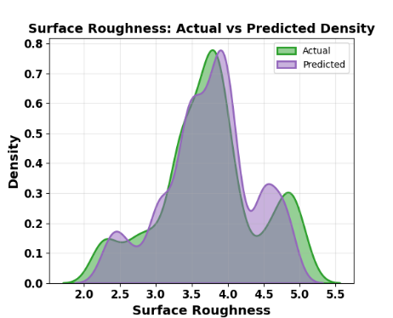

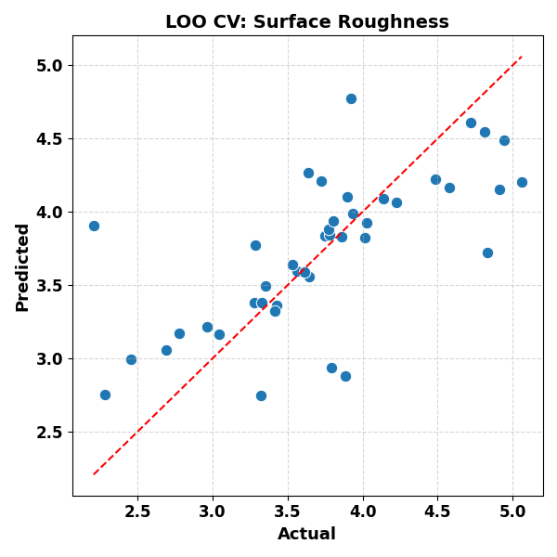
- (b) (c)

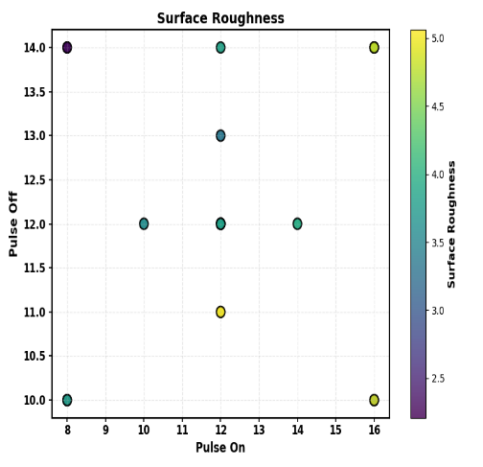
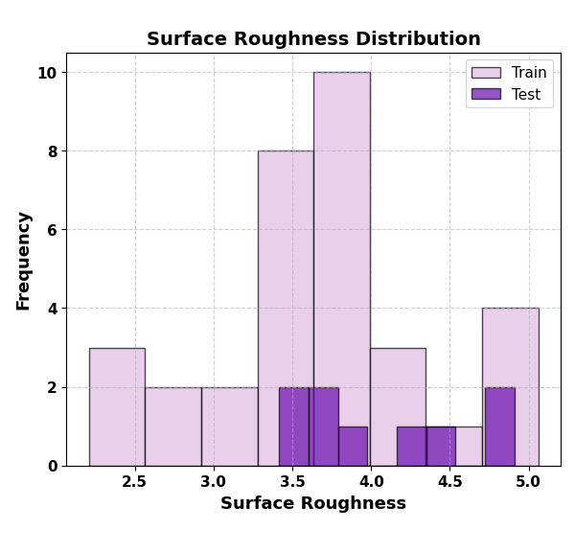

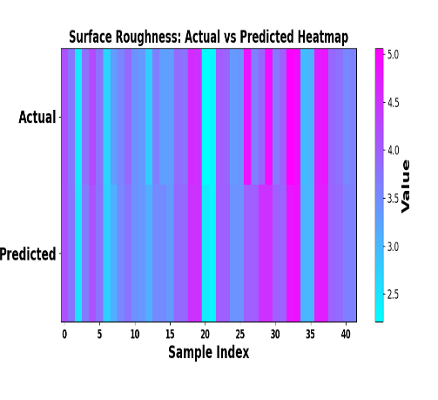
(d) (e) (f)
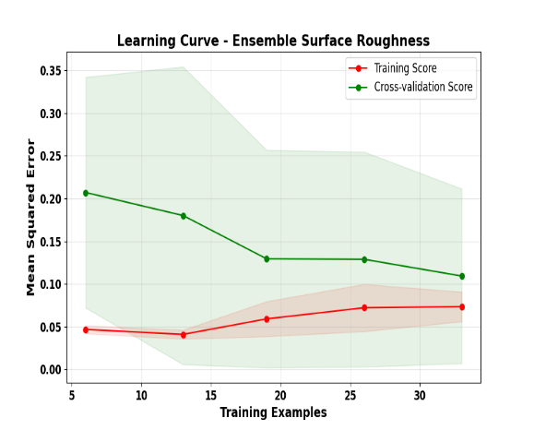
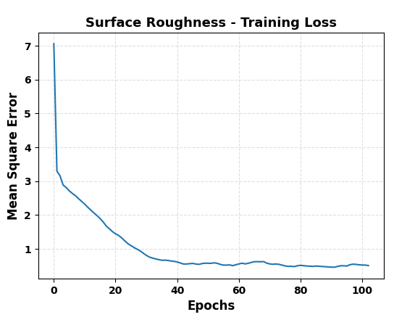

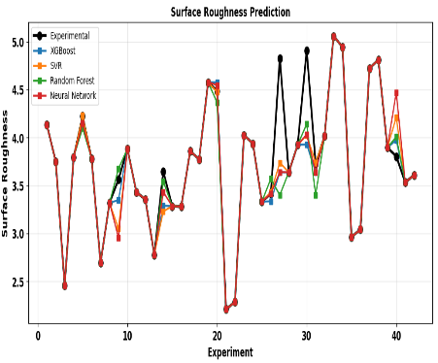
(g) (h) (i)
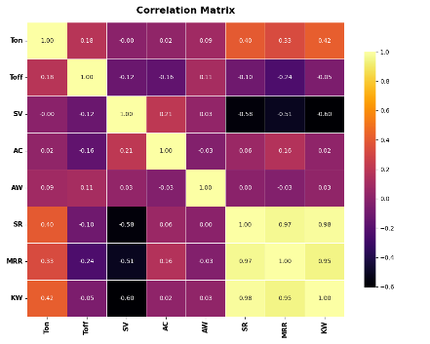
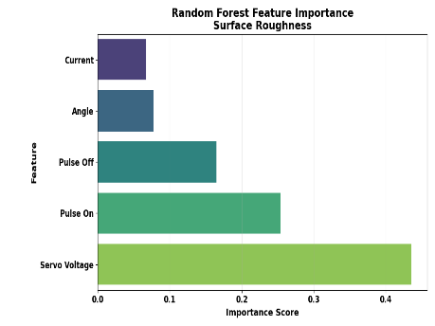

(j) (k) (l)
FIG: Ensemble Surface Roughness Model Performance(a) Bootstrap(b) Density curve (c) Actual vs Predicted value(d)Distribution(e)Parameter Space Analysis(f) Leave-One-Out Cross-Validation(g)Heatmap(h)Epoch(i)Learning Curve(j) Validation of model with experimental value(k) Random Forest Feature Importance (l) Correlation Matrix
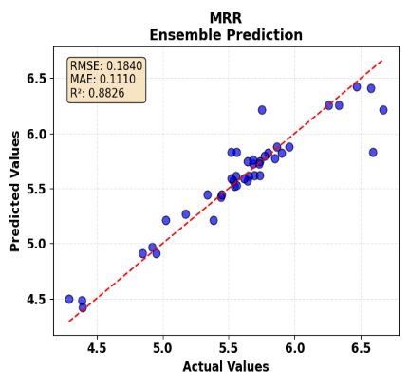
MRR
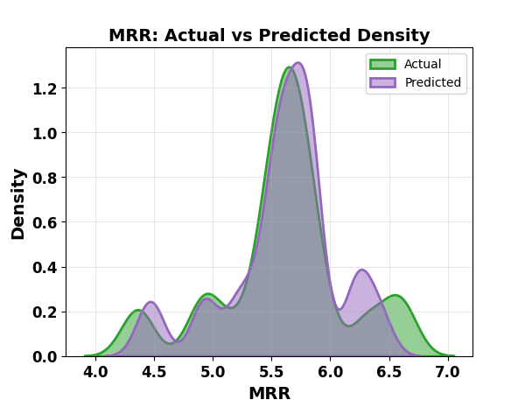
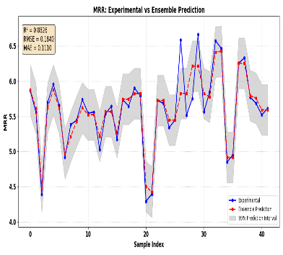

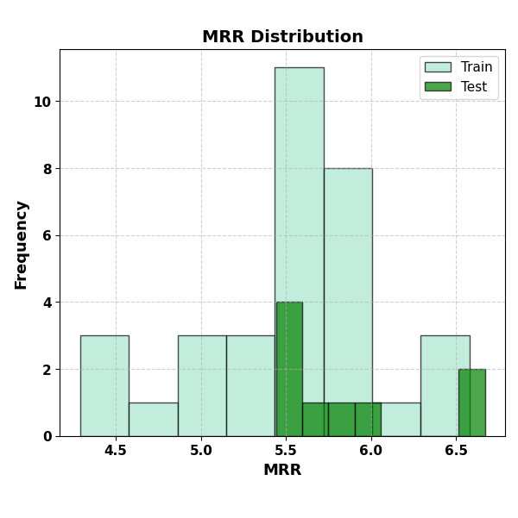
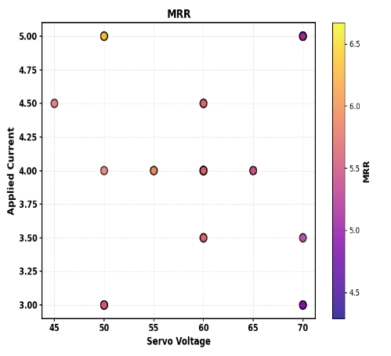
- (b) (c)
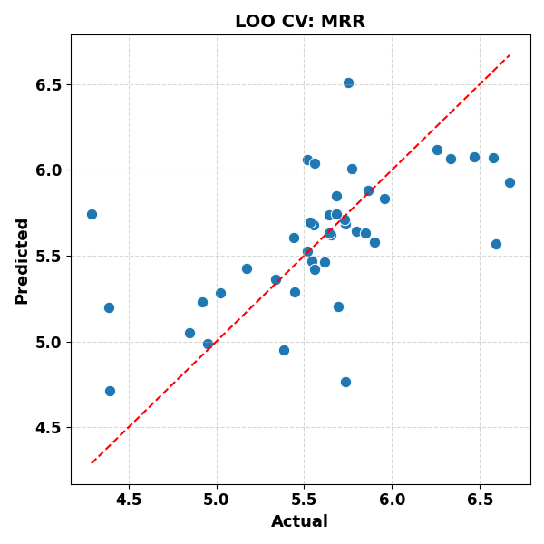

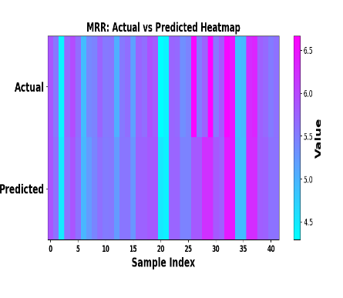
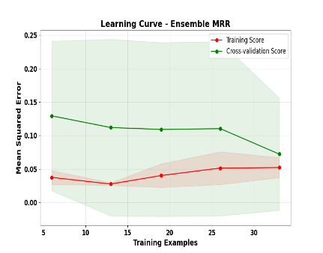
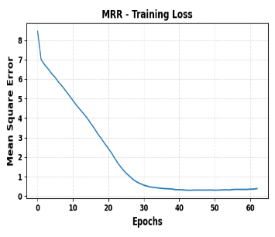
(d) (e) (f)

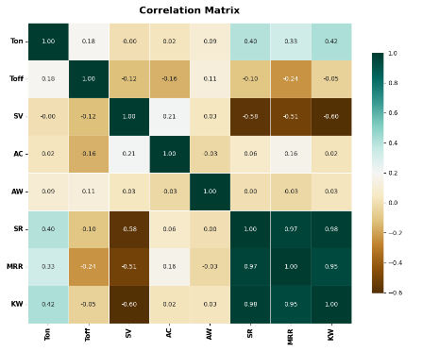
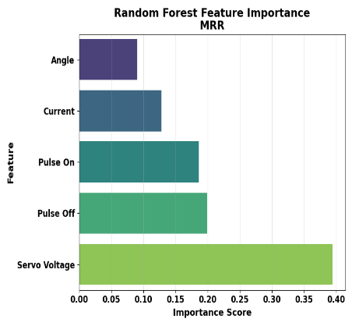
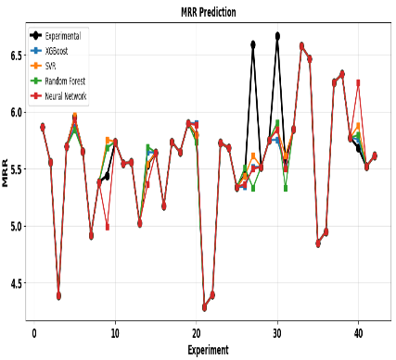
(g) (h) (i)

(j) (k) (l)
FIG: Ensemble MRR Model Performance(a) Bootstrap(b) Density curve (c) Actual vs Predicted value(d)Distribution(e)Parameter Space Analysis(f) Leave-One-Out Cross-Validation(g)Heatmap(h)Epoch(i)Learning Curve(j) Validation of model with experimental value(k) Random Forest Feature Importance (l) Correlation Matrix

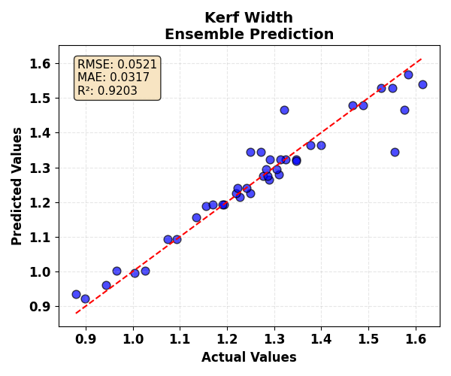
Kerf Width
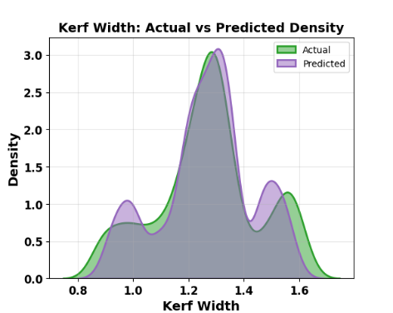
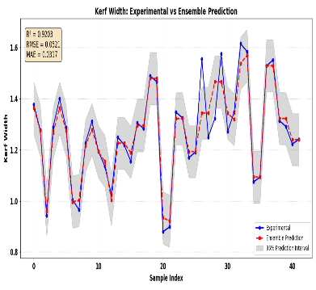

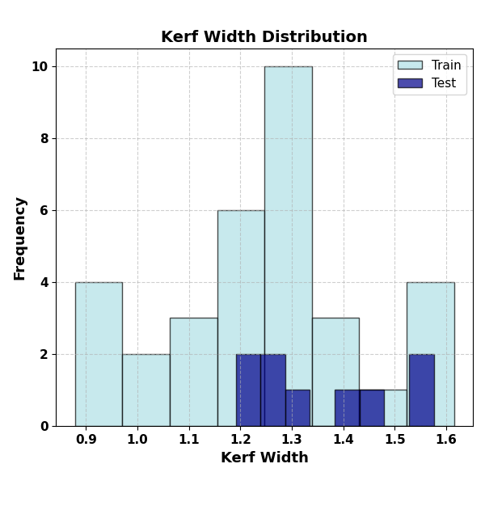
- (b) (c)
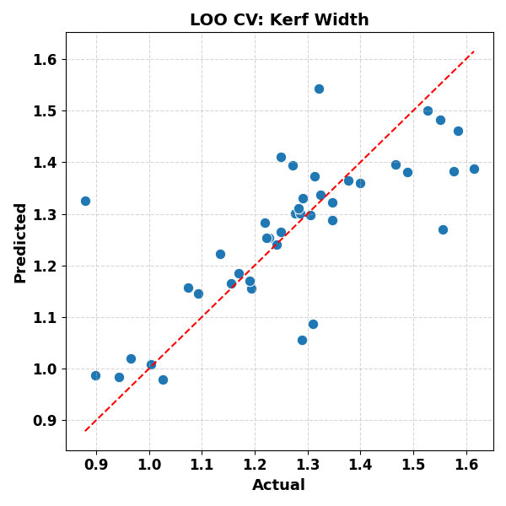
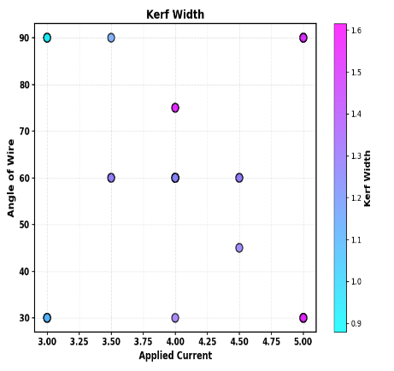

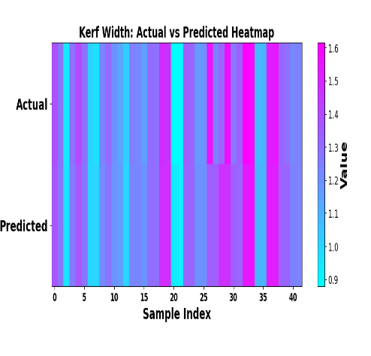
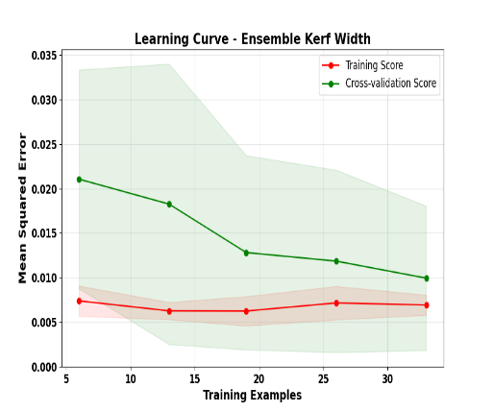
(d) (e) (f)
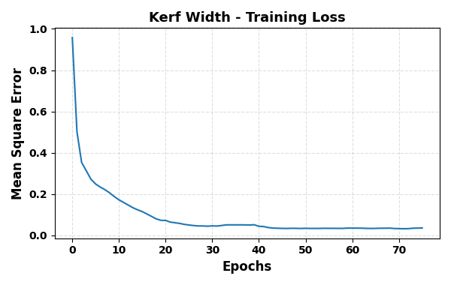

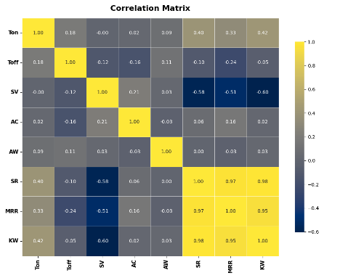
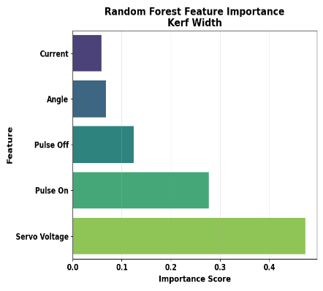
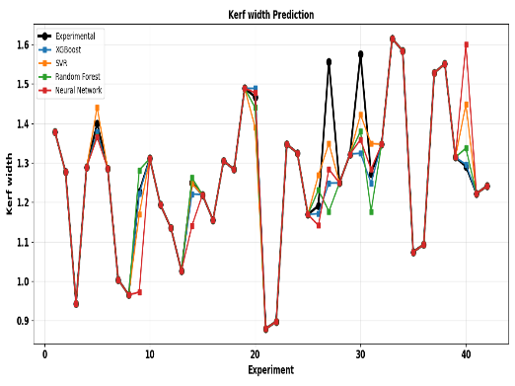
(g) (h) (i)

(j) (k) (l)
FIG: Ensemble MRR Model Performance(a) Bootstrap(b) Density curve (c) Actual vs Predicted value(d)Distribution(e)Parameter Space Analysis(f) Leave-One-Out Cross-Validation(g)Heatmap(h)Epoch(i)Learning Curve(j) Validation of model with experimental value(k) Random Forest Feature Importance (l) Correlation Matrix
Table 3: Optimal AWJM Process Parameter
Parameter | Min Kerf | Max MRR | Balanced
Pulse On (µs) | 8 | 12 | 8
Pulse Off (µs) | 14 | 11 | 10
Servo Voltage (V) | 50 | 60 | 50
Current (A) | 3 | 4 | 3
Angle (°) | 90 | 75 | 30
MRR (mm³/min) | 4.290 | 6.668 | 6.589
Kerf Width (mm) | 0.879 | 1.576 | 1.556
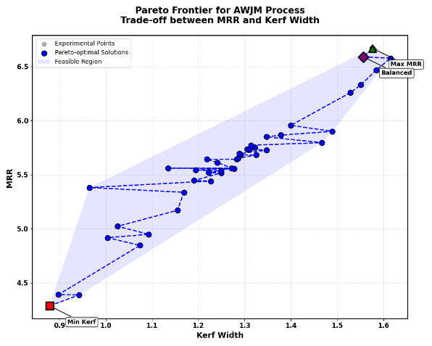

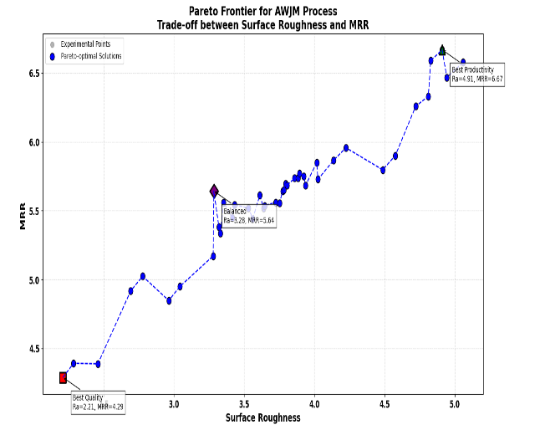
Table 3: Optimal AWJM Process Parameter
Parameter | Min Ra | Max MRR | Balanced
Pulse On (µs) | 8 | 12 | 12
Pulse Off (µs) | 14 | 11 | 13
Servo Voltage (V) | 50 | 60 | 60
Current (A) | 3 | 4 | 4
Angle (°) | 90 | 75 | 30
Surface Roughness (Âµm) | 2.209 | 4.910 | 3.284
MRR (mm³/min) | 4.29 | 6.668 | 5.643

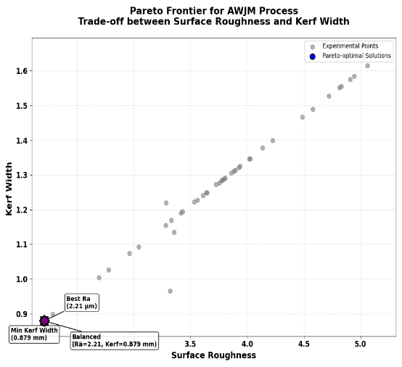
Table 3: Optimal AWJM Process Parameter
Parameter | Min Ra | Min Kerf | Balanced
Pulse On (µs) | 8 | 8 | 8
Pulse Off (µs) | 14 | 14 | 14
Servo Voltage (V) | 50 | 50 | 50
Current (A) | 3 | 3 | 3
Angle (°) | 90 | 90 | 90
Surface Roughness (Âµm) | 2.209 | 2.209 | 2.209
Kerf Width (mm) | 0.879 | 0.879 | 0.879

